Heart anatomy

Assessment Statements
- Draw and label a diagram of the heart showing the four chambers, associated blood vessels, valves and the route of blood through the heart.
- Outline the main principle behind the ECG technique and the medical background of the P, R and T peaks.
- Outline the mechanism of atherosclerosis and state the common risk factors
- Explain what a heart attack is and how a stent or a bypass operation can help

Anatomy of the heart
Mammals (and therefore humans too) possess a heart with four chambers. Each side of the heart is divided in an atrium and a ventricle with valves in between and after. The two sides are not connected directly and contain blood of different oxygen concentration. The atrioventricular valves are (as their name indicates) between the atrium and the ventricle. At the end of the ventricles (between ventricle and artery) are the semilunar valves. Both types of valves have special names for the right and left version:
- left atrioventricular valve: bicuspid valve or mitral valve
- right atrioventricular valve: tricuspid valve
- left semilunar valve: aortic valve
- right semilunar valve: pulmonary valve
Be aware that there are no valves between veins and atria.

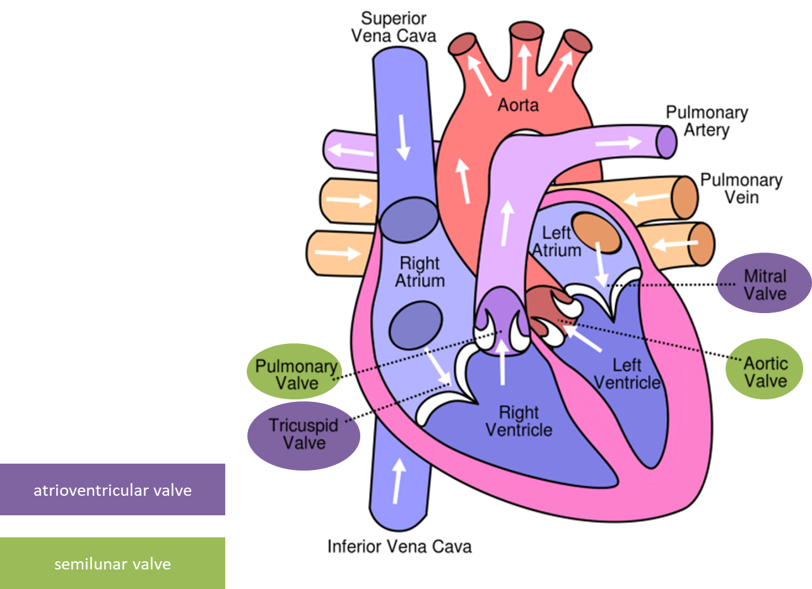

A more detailed illustration

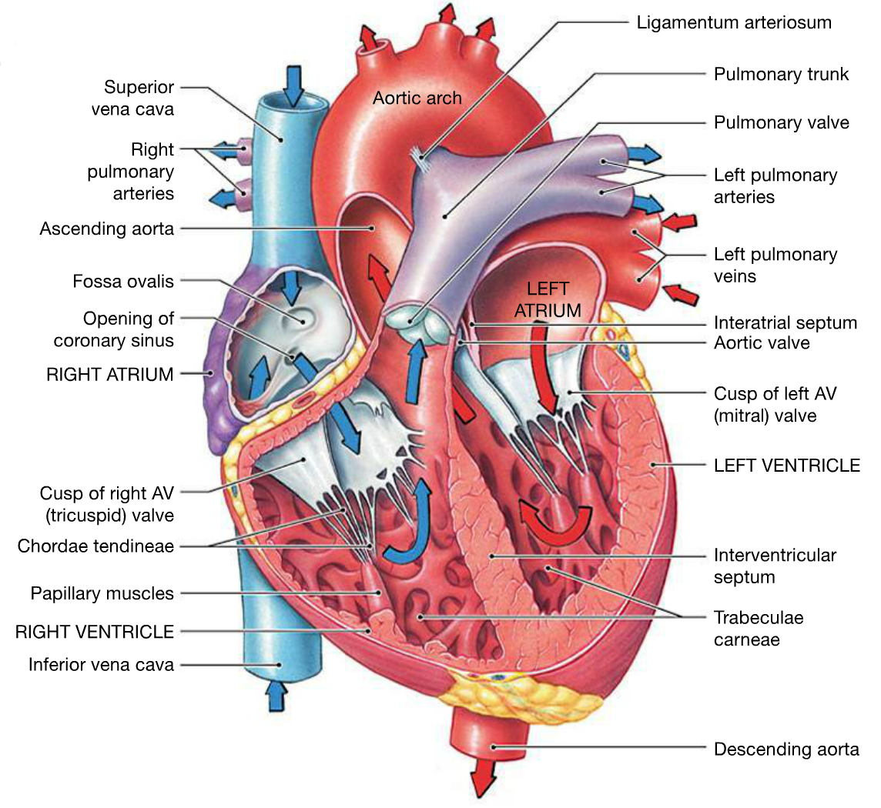

The working heart
term | explanation | measurement / calculation / estimation | normal value
heart rate | number of contractions of the heart per minute. | count pulse beats per minute (bpm) with fingers or with apparatus | 70 bpm (at rest)
blood pressure | systolic: maximum arterial blood pressure  diastolic: minimum arterial blood pressure | measured with blood pressure meter | 120 / 80  (systolic / diastolic)
pulse pressure | blood pressure difference caused by pulse | pulse pressure  = blood pressure_{systolic}  - blood pressure_{diastolic} | 40 mmHG
stroke volume | volume of blood pumped out with each contraction of the heart. | estimation:  stroke volume  = pulse pressure · 1.75 | 70 ml
cardiac output | volume of blood pumped out by the heart per minute. | cardiac output  = heart rate · stroke volume | 5 l / min (at rest)
venous return | volume of blood returning to the heart via the veins per minute. | at rest, 70% of the blood is in veins. Changing a position (e.g. get up from bed) has influence on venous return and as a consequence on blood pressure (and then on heart rate)

Please note these values are only rough estimates and could vary strongly for individuals. They are dependent on gender (usually women are smaller than men), training and anatomy. As an example, the values for stroke volume (and therefore also for cardiac output) are 25% smaller for women (this means ~60 ml for female stroke volume).
The total blood volume of a typical male is around 5l. You notice our entire blood flows through our heart in only one minute (at rest, during sport activities it is even faster)!

My own heart values
Measure or calculate these terms with your own values:
blood pressure: 130/90
heart rate: 75

pulse pressure = blood pressure_{systolic} - blood pressure_{diastolic} = 40

stroke volume = pulse pressure · 1.75 = 70

cardiac output = heart rate · stroke volume = 5250 ml

Coronary blood vessels
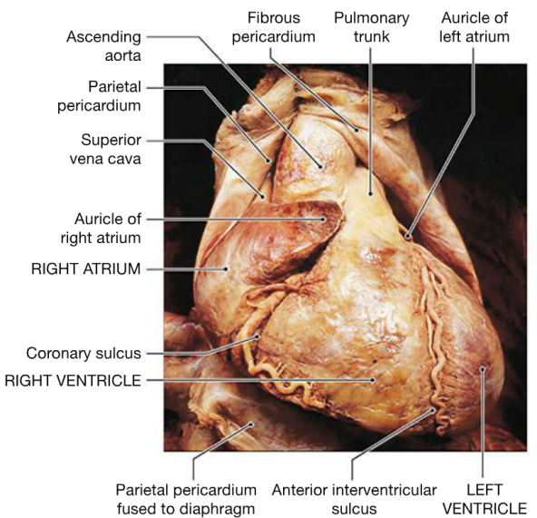
Soon after leaving the heart with oxygen-rich blood the aorta gets divided into different main arteries which transport blood to all body parts. However, there is one organ which is not supported this way: The heart itself.
At the very beginning of the aorta, small coronary arteries leave the main blood vessel and supply the heart muscles with oxygen and nutrients. Coronary veins deliver blood with carbon dioxide and waste products into the right atrium.
The heart is enveloped in a bag, the pericardium. The sulci are channels filled with coronary arteries and fat tissue. They show the separation of atrium and ventricle from the outside.

Electrocardiography ECG
Every muscle contraction is preceded by an electric activity which can be measured with an ECG. ECG is a noninvasive technique to analyze the heart size and position as well as some malfunctions. However, the interpretation of an ECG curve is difficult, and interpretation needs experience and time.
So, the aim of this task is to understand the principle of the ECG (which part of the diagram corresponds to which heart activity) and to learn how one measures an ECG – not to find heart disorders.
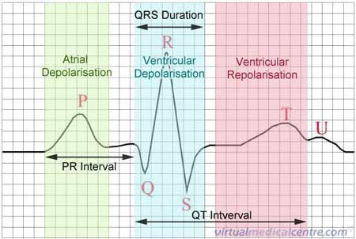
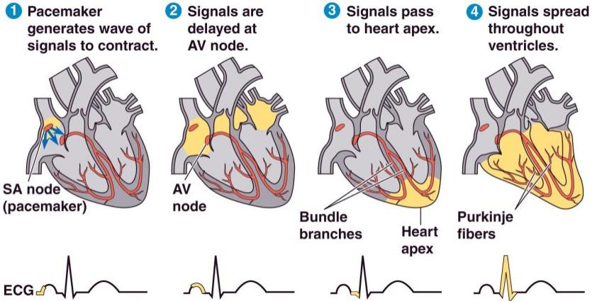

My own ECG curve
- Lay down and do not contract your muscles. Do not move; let your colleagues do the further jobs.
- Look at the manual and stick the sensors as indicated. Colors must fit!
- Click on collect (top right green button)
- If the curve doesn’t look good: Change your position gently or reattach the sensors, click again on collect. You may need adhesive tape to firmly attach the sensors to your skin.
- Try to find the P, Q, R, S and TU regions in your curve. Discuss what your heart does at the P, R and T peaks.
- Put back all the material. The sensor sticks must be reused.

Heart attack (myocardial infarction)
When the blood flow in the coronary arteries is blocked too little oxygen is delivered to some parts of the heart muscle. The muscle cannot maintain its function and the heart stops to beat. This can be life-threatening in a very short time.
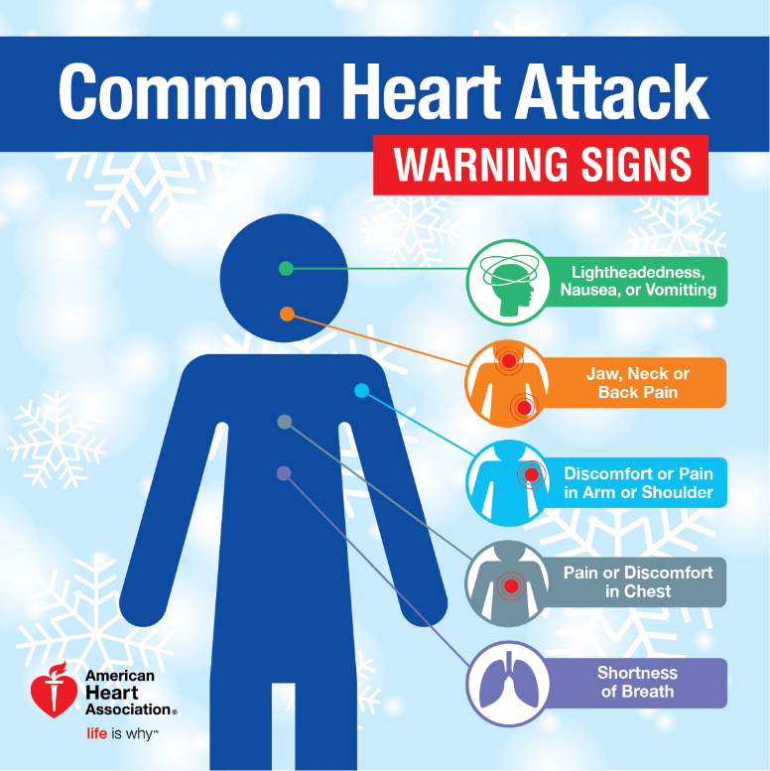

Immediate treatment
- calm down patient, ask to respire calmly and deeply
- if heart stopped to work perform cardiopulmonary resuscitation (CPR) (heart pressure massage)
- call emergency doctor

Acute treatment in the hospital
- oxygen delivery
- pharmaceuticals against pain, fear
- pharmaceuticals (nitrates) to widen blood vessels
- pharmaceuticals to lyse thrombus
- if heart stopped to work defibrillation is necessary

Therapy

Pharmaceuticals
- to lower blood clotting tendency (e.g. aspirin)
- to lower blood pressure (beta blocker)
- to widen blood vessels (ACE inhibitor)

Balloon angioplasty

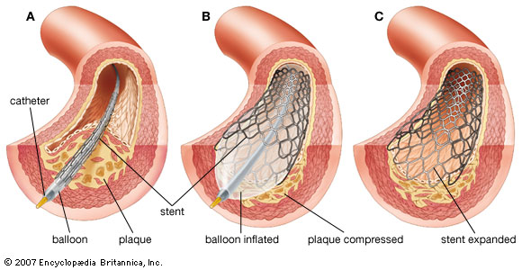

Coronary artery bypass surgery

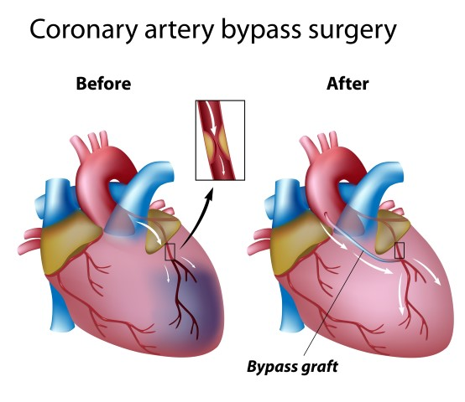

Used Tools and References
- MADER, S. S., WINDELSPECHT, M. (2014): Human Biology. McGraw Hill. New York. 13th edition.
- ASHWELL, K. (2011): The anatomy student’s self-test visual dictionary. Hodder Arnold. London.
- MARTINI, F. H., BARTHOLOMEW, E. F. (2013): Essentials of Anatomy and Physiology. Pearson Education. San Francisco. 6th edition.
- SIMON, E. J., REECE, J. B., DICKEY, J. L. (2013): Essential Biology with Physiology. Pearson Education. San Francisco. 4th edition.
- REECE, J. B. et al. (2018): Campbell Biology. Pearson Education. San Francisco. 11th edition.
- https://en.wikipedia.org/wiki/Heart
- https://hudsonvalleyny.heart.org/know-signs-holiday-heart-attack-get-help-fast/
- https://myheart.net/articles/heart-bypass-surgery-explained-in-incredible-pictures/

CC BY 3.0 for contents created by Daniel Margadant
For other sources (e.g. figures) please consider © of corresponding reference

